GENERAL NOTES

Objectives

The main objective of this laboratory is to teach you the practical techniques and procedures of experimental organic chemistry. A further objective is to enhance your understanding of the facts and theories of organic chemistry by having you consider them in a laboratory setting. It is hoped that at the end of the course you will understand the physical and/or chemical consequences of each step of a procedure as you carry it out and that you will be able to troubleshoot small experimental errors and salvage experiments. The spring semester course is designed to extend these original goals and to have you begin to work like real chemists in that you will be utilizing more library resources and working more creatively and independently.

Organic chemistry is a creative science in which the synthesis of complex and previously unknown molecules plays an important role. To provide you with efficient, safe, and relatively inexpensive training, however, the syntheses you will undertake in this laboratory involve only simple and well-known molecules.

Many of you who carry out chemical, biological, or medical research in the future will use the training you receive in this laboratory directly in that research. All of you, I hope, will use the mental development, organizational skills and manual dexterity gained by this course in many facets of your life. For example, you may find that your cooking skills are greatly enhanced! Hopefully, you will be excited by what you learn, but you will also realize how little we really know, how much more there is to learn. There is an infinite amount of study to be done and discoveries to be made!! One’s understanding can always be enhanced!!

“I am the wisest man alive, for I know one thing, and that is that I know nothing.”

Socrates

Texts

If you ever find you need more background on any subject covered in this manual, please visit my website at http://www.brynmawr.edu/Acads/Chem/mnerzsto/index.html. It is very important that you be very focused in on the schedule page of the lab manual. It is the source of information (including this!!!). There you will find links to the labs, links to very helpful youtubes (we hope). There are youtubes on nearly every subject, please make use of them. Seeing the technique done in our lab is a great advantage before coming. References to these youtubes will be highlighted.

Notebook and Lab Reports

The required notebook for this course, without exception, is the "Laboratory Research Notebook", which is available from the Book Store. This notebook has alternating white and yellow pages numbered in pairs (i.e., there are two pages numbered 1, two numbered 2, etc.), made of carbonless paper. You are to make a copy on the yellow sheets of everything written on the white sheets. Your notebook is to be a complete (and immediate) record of every observation you carry out in this laboratory.

At the end of each laboratory period, the yellow copies of the pages you have used in that period should be removed neatly from your laboratory notebook, stapled together, and handed in to your teaching assistant. This protects you from suffering a disaster if your laboratory notebook is misplaced, lost , or accidentally destroyed. The yellow copies of the remainder of your laboratory write-up will be collected by your TA during the laboratory period one week from the day the experiment was scheduled to be completed. Pre-lab exercises will be assigned for almost all experiments. These are to be answered in your lab book and turned in to your teaching assistant (here after referred to as your TA) before beginning lab work. If you cannot answer these questions, you should get help from your TA or instructor.

Your lab report may also be written using a computer, but the raw data must be in your notebook. These sheets will be collected each week. DO not keep your laboratory data on loose pieces of paper, your hand, etc.

Except for some modifications described in individual experiments (e.g. the first few labs and the form write-ups), you are to follow the detailed instructions regarding the laboratory notebook below. Reserve the first three pages for an index, and keep this current each week. Note that part of the write-up for a given experiment is to be completed before you come to lab.

The experiments that we will do are divided into two main types:

Investigative experiments are designed to answer a question or determine a property of a substance (and of course often to teach a technique). For these types of experiments you should use the rather flexible format described below.

- Answers to Pre-lab Exercises

These exercises are assigned in this lab manual. The answers should be written in your notebook or stored on your computer. A copy of this assignment is turned in upon entering the lab to do the corresponding experiment.

- Introduction

This section should consist of a paragraph or two describing the purpose of the experiment. Not only should the immediate purpose be stated, but the "big picture" goals should be defined. The big picture goal might be … “ This lab trains the student in an important technique used to separate organic compounds”. You should also give a reference for the procedure to be followed, e.g., Lab Manual, p. ##. This section must be completed before coming to lab.

Ill. Experiments and Results

This section is really a big, flexible data table. For each major part of the experiment, a descriptive heading is written and a space beneath is left blank for recording data and observations associated with that part of the experiment. Processed data also belongs in this section, e.g. graphs, calculations, etc. The setup of the data tables should be completed before lab, raw data is recorded directly into the notebook during lab and calculations are completed during or after lab. . The yellow sheets corresponding to this data must be turned in at the end of lab.

IV. Discussion

In this section, draw any reasonable conclusions from the data and state whether or not the goals of the experiment were achieved. Carry out a thorough error analysis and state any improvements that could be made in your procedure to get better results. This section is completed after lab in lab after lab in your notebook or on your computer..

V. Answers to Exercises

The exercises are assigned in this manual. They should be completed in your lab notebook after carrying out the experiment.

Preparative experiments involve the organic synthesis of molecules or molecules. For preparative experiments you should use the format outlined below. In this format, Sections I through VI constitute the pre-lab write-up that must be completed before you come to lab. Section VII should include all of the notes that you make while the experiment is in progress. Section IX should contain any conclusions that are called for in the instructions, along with detailed error analysis and suggestions for improvement if the experiment did not proceed as well as it might have. A sample lab report follows the format below with the exception of raw data observations (must be in notebook) or on your computer.

Format for Preparative Experiment Lab Reports

Experiment #: |  | NAME:
Date: |  | TA:
Title:

- Introduction - In a few words, describe the reaction to be carried out, and give a summary of how the products are to be analyzed. State the "big picture" goal (described earlier). Give a reference to the procedure (either this manual or literature reference) along with any modifications that you have been instructed to follow. Do not write out the procedure (in your notebook or a computer).

- Main reaction and mechanism - write the reaction you are going to carry out and its mechanism using the arrow formalism (in your notebook or a computer).

- Potential side reactions and how the procedure is designed to minimize them. Mechanisms are not required here. These will be explained in more detail when we carry out the first preparative lab.

- Purification - a verbal description of how the main product is separated from the side products, unreacted reagents, catalysts, and solvents. Begin by naming or drawing the structures of all the substances (including possible side products) present in the reaction mixture when the reaction is complete. Describe how each is removed. This can be done in a tabular form. This will be explained in more detail when we carry out the first preparative lab.

- Table of reagents (This will explained further on future date.)

 |  | Amount used:
Compound | Mol. Wt. | Grams | Moles | MP_ | BP | Density
(Give the BP and density for liquids, but only the MP for solids. List only reagents, not solvents or catalysts.)

- Table of products (This will explained further on future date.)

 |  | Amount used:
Compound | Mol. Wt. | Grams | Moles | MP_ | BP | Density
(This much constitutes the material to be written out before coming to lab in notebook or word processor.)
----------------------------------------------------------------------------------------------------------
- Observations and data - record significant observations, color changes, etc., and any data collected. (record in notebook during lab)

- Results (record in notebook during lab)

Yield (grams, moles, %):
Properties of product:
Physical state, appearance, MP or BP:
Results of chemical and solubility tests (if any):
Results of GC or IR (if done, normally attached):
Analysis of spectra (if assigned):

- Discussion - whether the objective of the experiment was achieved (in most cases whether the desired compound was obtained reasonably pure and in good yield, and if any questions were answered by the experiment), and a summary of the evidence that supports that conclusion. The discussion should include an error analysis, i.e., reasons for low yield, possible contaminants and it should include a summary of evidence supporting the identity of product. (in notebook or computer)

- Answers to assigned problems (in notebook or computer). *************************************************************************************
Starting on page G-7 you will find a sample preparative lab write-up for a typical preparative experiment.

Some Suggestions for Writing Lab Reports

While reading applications of students to Bryn Mawr College, I came across some very interesting essays. Two essays in particular come to mind as I am writing these suggestions. One student was discussing the problems with the American education system. Her basic viewpoint was that we eat out dessert first and then our vegetables and so even the brightest students can be overwhelmed with challenging college courses. The other student was a member of problem solving club which in small teams competed to solve novel problems. Her team had adopted the motto, "K.I.S.S.", which was an acronym for "keep it simple, stupid". She had learned through her experiences that problems which seemed insurmountable often had very simple solutions because they were not impossible, just different.

I realize that organic chemistry can seem like a massive pile of the most evil tasting vegetable, but it is a vegetable that is good for you and you can acquire a taste for it. As my mother used to say, "Try it, you'll like it!" My expectation is that the students in this course will do their best to develop their analytical capabilities and this is why I try not to spoon feed you the answers. I want you to get more out this course than just a head jumbled with organic reactions. I want you to learn how to think, i.e., to develop your problem solving capabilities so that you can use your experiences from this course in non-chemistry situations. It is not my expectation, however, that you will spend inordinate amounts of time writing lab reports. Ten to fifteen hours a week on lab report is too much and it really worries me that some students use so much time. Five to seven hours is a healthier time frame. I appreciate perfectionism, but at some point you have to stop working and turn in your work.

To keep your work time and frustration levels low, you should adopt the motto, KIS (keep it simple). How can you keep it simple? Well, first you have to decide that you are going to develop priorities in using your five to seven hours of work time. You should decide to put most of your time into the assigned readings, thinking about your data and the solutions to the assigned problems. You should minimize the time you spend actually writing the report. Choose not to write the entire report on scrap paper and copy it over. Write your work directly into the note book or on your computer. No one will get annoyed if you cross something out as long as the answer is legible. Alternatively, you can word process your report as long as you record raw data in your notebook. Though I don't recommend this because I know that most students get carried away while word processing. Be as concise as possible in answering questions. Lengthy essays are not required. Answer in a word, phrase or equation if possible. Minimize the amount of time you spend doing things that are not very beneficial to your mental development. For example, try not to become obsessed with finding a melting point or density. If you can't find it on the website (try Chemfinder, for example) or in the CRC or Merck in five or ten minutes, ask about it. If you can't make it to office hours, call (610-526-5102), e-mail (mnerzsto@brynmawr.edu), write a note, or just bring your problem to lab. I have always been and will always be flexible about pre-labs. When you write answers, keep them short. If an equation or mechanism can be used, use this in lieu of words (this is our true chemical language at this point). You can write lists instead of paragraphs. Use phrases instead of sentences. This sort of language is actually closer to the concise wording used in a chemistry paper. This is all good as long as when you are done writing you have answered the question or described the phenomenon at a molecular level and have fully explained it. We are looking for succinct, deep answers, not wordy vague answers.

Now, how about approaching novel problems? Well, once again, keep it simple. The solutions to these problems are not exotic. They are based on fundamental information that is given in the lab manual, readings or lectures. It is just a matter of gaining enough confidence in yourself to put basic ideas together in a new way. Generally, it is very important to realize that I am most concerned with your mental development. I would rather that you thought for 10 minutes or so and try your best to answer the question than scurry around the building for an hour trying to find someone who can give you the best answer. I really feel that the worst mistake you can make in this course (and it is frequently made) is to put all your time and emphasis on finding the absolute answer rather than thinking on your own feet. There is so much to be gained by thinking even if you do get some answers wrong. Side reactions always give students some trouble so I will use them as an example. Side reactions are anything that lowers the yield of a reaction chemically. Answering the following questions should lead you to the relevant side reactions.

1 Does the reaction have another possible regiochemistry (e.g., anti-Markovnikov vs. Markovnikov addition) or stereochemistry (e.g., endo vs. exo)? Any product derived from the less desired route is considered a side reaction.

- Does the reaction produce an intermediate that rearranges? If rearrangement is possible, any products derived from undesired rearrangements are side reactions.

- Are any of the reagents or products sensitive to the laboratory atmosphere? For example, does anything react with water or gases in the air? If so, other side products will form because one can't completely eliminate the atmosphere under our crude lab conditions.

- Are there functional groups in the reagents that are not necessarily involved in the desired chemistry, but are sensitive to the conditions of the reaction? For example, a double bond and a hydroxyl group can react with aqueous acid. Here and everywhere, you are not expected to come up with reactions that have not yet been covered.

- Finally, is the reaction such that a component involved in the reaction might undergo the same type of reaction with itself.

In any event, you will get stuck every once in a while. If you do, don't beat your head against the wall! Come to office hours, write a note, call, e-mail or just bring the problem to lab! Please bother me!
Science is built of facts the way a house is built of bricks; but an accumulation of facts is no more science than a pile of bricks is a house.

Henri Poincare, La Science et l'hypothese (1902)

SAMPLE PREPARATORY LAB REPORT

Reduction of Acetophenone
- Introduction: 1-phenylethanol will be prepared by reduction of acetophenone with sodium borohydride. The product will be characterized by its IR spectrum. Reference: Book, pp. ##, except that dichloromethane will be used as the extracting solvent instead of diethyl ether the vacuum distillation will be omitted, and acetophenone is being used in place of benzaldehyde. This reaction will demonstrate at an experimental level and reinforce in the theoretical sense the hydride reduction of carbonyls. This reaction demonstrates an important synthetic method.

- Main Reaction
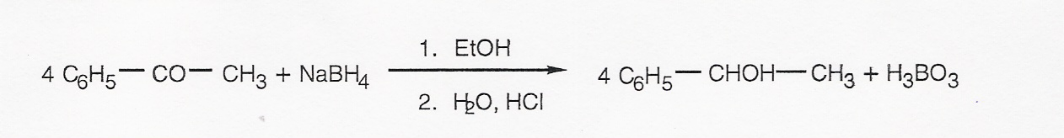
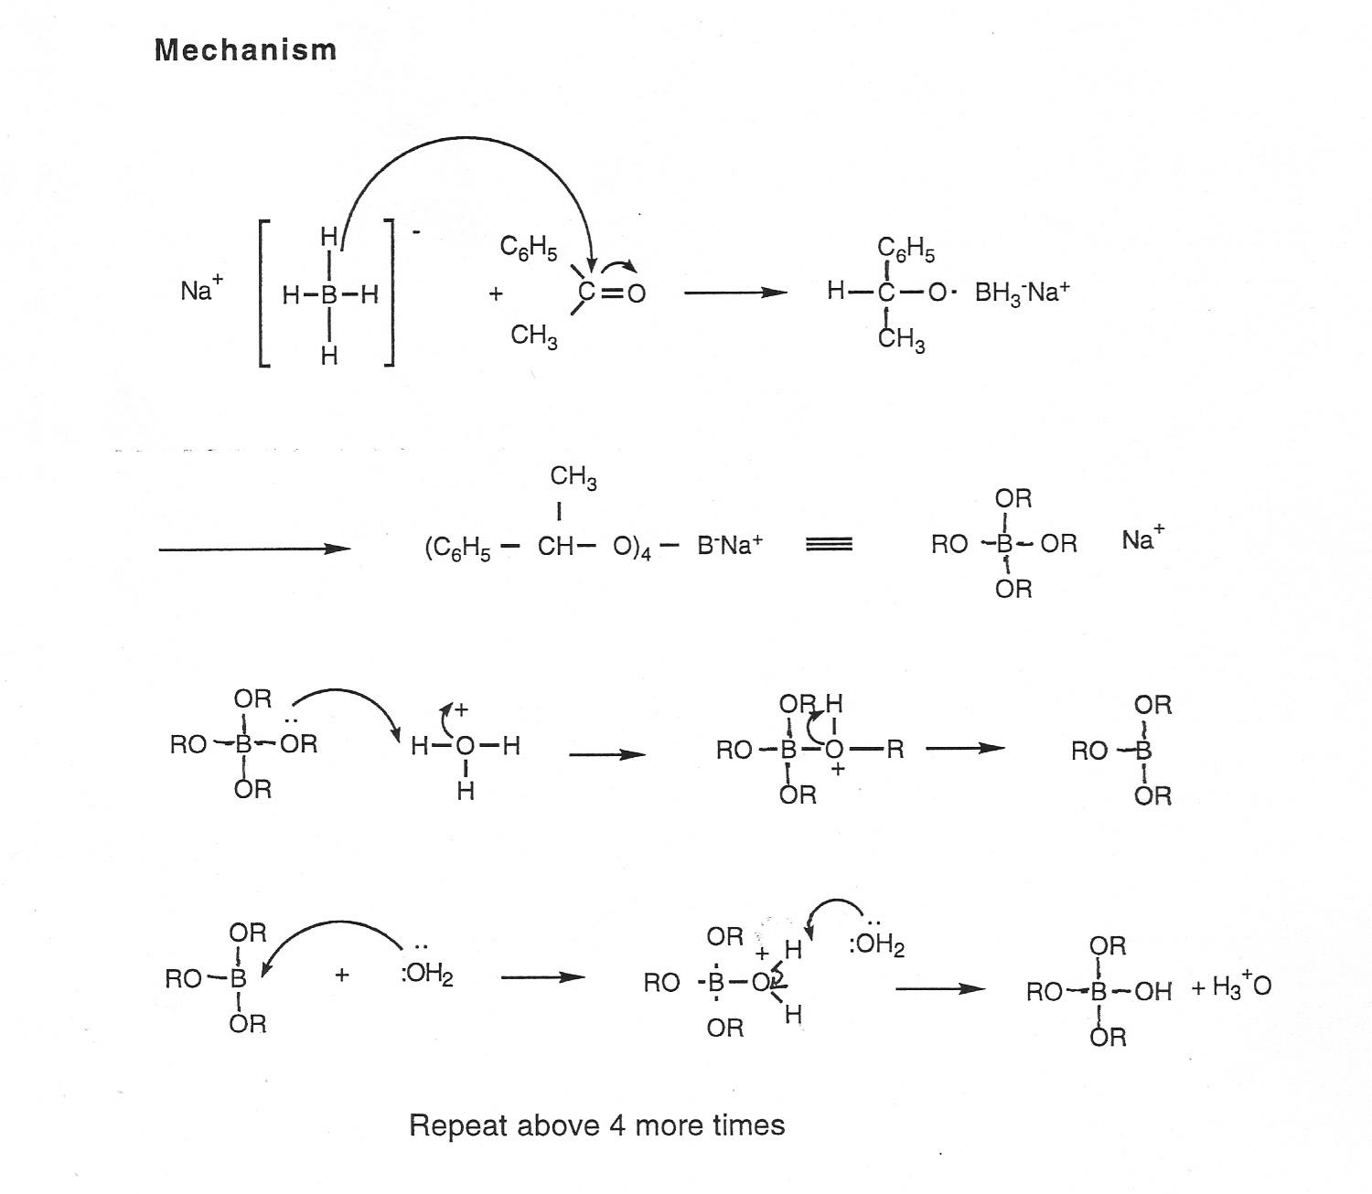
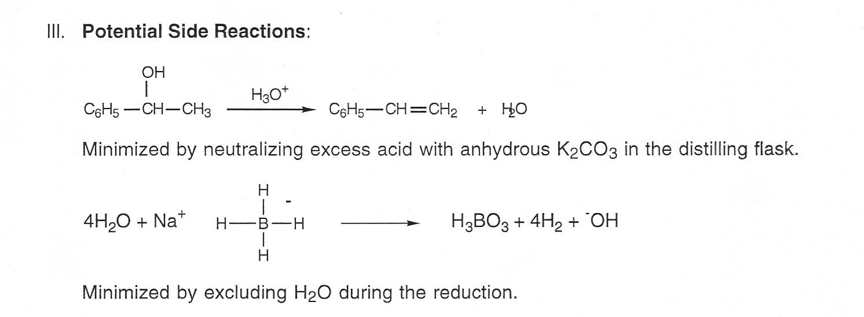

III. Mechanism
IV. Purification: The reaction mixture contains (in addition to the product) water, ethanol, inorganic salts and acid.

- The steam bath evaporation removes the ethanol and some water.
- The extractions with dichloromethane separate the product from the inorganic salts, most of the water and acid. The product is quite soluble in CH₂Cl₂.
- The backwash with K₂CO₃(aq) neutralizes acid in the organic layer.
- The addition of MgSO₄(anh) removes any trace amounts of water in the organic layer.
- The rotary evaporation removes the methylene chloride.

V. Table of Reagents

Amount used
MW grams/mL moles MP BP Density
NaBH4 37.8 1.2 0.032 400d** --- -- ***
acetophenone 120.16 12.0 0.100 -- 202 1.0281
hydrochloric acid (3M) -- -- 0.03 -- -- -- ****

** melts with decompositon
*** Not needed for solid
**** Not needed for solution

VI. Table of Products

Theoretical. yield
MW moles grams BP Density

1-phenylethanol 122.17 0.100 12.2 203 1.0135

VII. Observations and Data

The reaction proceeded as described. The white precipitate which formed after the initial reaction was dissolved by about 8 ml of HCI, but the remaining 2 ml was added anyway as specified in the procedure.

VIII. Results
Yield was 22.2g-13.5g (tare) = 8.7g
((Actual yield in grams or moles) ÷ (Theoretical yield in grams or moles)) X 100 = % yield
8.7g ÷ 12.2 g = 71%

The product was a clear liquid with a somewhat "glassy" appearance and a pungent odor. Its B.P. was not determined.

The IR spectrum of the product is attached. (Analysis omitted here. In an actual lab report you would analyze the IR spectrum in this section.)

- Discussion: The IR spectrum measured for the obtained liquid product was consistent with it being 1-phenylethanol as outlined in the analysis given in the previous section. Comparison of the experimental spectrum with the literature spectrum for 1-phenylethanol (website) further confirmed the conclusion that the isolated compound was indeed 1-phenyl ethanol as the peaks occurred at the same frequencies and with similar relative intensities. The identity of the product could have been further confirmed by measuring other properties such as boiling point and measuring other spectra such as NMR.

Though no catastrophes occurred while carrying out the procedure, there are several explanations for the less than perfect yield of the obtained product. The reaction did not go to completion as evidenced by the small C=0 peak visible in the IR. This carbonyl is most likely due to the presence of a small amount of unreacted acetophenone. The reaction may not have gone to completion due to inadequate heating and/or reaction time during the reduction or more likely, due to the side reaction of sodium borohydride with contaminating H₂O. There were slight losses throughout the procedure due to transfers (material left in discarded layers) and drying (material absorbed into the drying agent).

The IR spectrum gave evidence for the presence of several contaminants. As mentioned previously in this discussion, a C=0 absorption is visible in the IR spectrum indicating the presence of acetophenone. The OH absorption is also much larger (relatively speaking) than that observed in the literature spectrum. This is probably due to some water contamination in the sample or water adsorbed onto the IR cells. Finally, there was no indication that styrene (potential side reaction) was in the sample. A purer product could have been obtained by carrying out a vacuum distillation.

- Exercises (omitted here).

HONOR CODE

Lab reports are to be written up independently. While it is reasonable to ask the instructor/T.A. for guidance, it is not acceptable to ask fellow students for the specific answers to questions or to compare answers to questions. It is also not permissible to consult graded lab reports or exams (unless provided by the instructor) from the prior academic year or to work in groups while actually writing lab reports. You are encouraged, however, to discuss general concepts with one another. For example, it is perfectly acceptable to discuss the assigned readings and lecture notes with a classmate. It is also permissible to hash through the procedures together to make sure you understand them. I urge you to work in groups under the described circumstances and especially when you are studying for exams!

GRADING

You will be evaluated by your TA on each experiment you carry out according to the criteria listed below. The points assigned to each section will vary slightly from experiment to experiment.

Investigative experiments:
Pre-lab exercises | 20 points
Introduction | 10 points
Experiments and Results | 40 points
Discussion | 30 points
Answers to exercises | 20 points
Quality of results | 20 points
Total | 140 points *
Preparative experiments:
Pre-lab exercises | 20 points
Pre-lab write-up (Sections I-VI) | 60 points
Completed lab report (Sections VII-IX) | 50 points
Answers to questions (Section X) | 20 points
Product (yield, purity, appearance) | 20 points
TOTAL | 170 points*

* All reports have equal weight in your final grade since they are all scaled to 100 points.

Your grade for the laboratory portions of Chemistry 211 and 212 will be based mostly on your understanding of the experiment and associated theory as reflected in the grades on each of your individual laboratory reports and your scores on the laboratory exams. The quality of your results is worth 20 points on most labs. You can have terrible results and score well on lab reports. Therefore, it is always worthwhile to turn in a report. It should also be mentioned at this point that the instructor does not require students to start over when an error is made. In fact, it is discouraged! There is very little to be gained from repeating the procedure. It is wasteful and students seldom learn much from the experience. Whenever you make an error, talk to your instructor. The experiment can usually be salvaged and you will learn more. It is important to realize early on that you are in lab to learn and not to perform. You simply can't always perform like an expert when you are a novice.

Please note that Prelab Exercises must be turned in at the beginning of lab lecture (even if you attend lab lecture on a day prior to your lab). Turn your Prelab in to your TA at the beginning of lab lecture. If you cannot do this for some reason, you must talk to your instructor or use the free extension form (there is one, no questions asked, free extension form in the laboratory manual on page on page G-15).
Completed laboratory reports are due by 2:00 PM ONE WEEK AFTER THE DAY THE EXPERIMENT IS SCHEDULED TO BE COMPLETED. Teaching Assistants cannot grant extensions. One "free, no questions asked" extension will be allowed for each student during each semester. To obtain this extension, you must fill out the form on page G-15 of this manual and staple it to the late lab report. The extension is for one week and is not transferable to the next semester. The extension must be requested in this way, so that your instructor can keep an accurate record. Your first extension must be taken this way. You can't save the form for a rainier day. Any extensions beyond this "free" extension must be granted jointly by your dean and your instructor. Your dean's approval must be secured first. Any reports turned in late without an extension or reasonable situation will be automatically graded down according to the following schedule.
Lateness | Penalty (% of grade earned)
1-7 days | -5%
1-2 weeks | -10%
2-3 weeks | -15%
3-4 weeks | -20%
4-5 weeks | -30%
Over 5 weeks | -40%
Graded reports will be returned to you in lab the following week. Please let your instructor know if your labs are not returned in a timely fashion.

In Semester I, the absolute deadline for all written work, including reports for any experiments carried out during the final make-up session, is 5 PM of the last day of classes in December.

Hours and Attendance

You will be permitted to work in the laboratory only during the hours and on the particular day of the week that your laboratory section is scheduled, except that you may weigh solid products and determine their melting points during any time the lab is open. The lab will be generally open from 10-5:30 each day, including Friday. The lab will not be open on Saturday. DO NOT ASK A TEACHING ASSISTANT OR ANOTHER INSTRUCTOR TO OPEN THE LAB OR SUPERVISE YOU AT UNSCHEDULED TIMES. This is not their responsibility, and they have been instructed to refuse such requests. When the lab is not in session and no arrangement has been made with the lab instructor, you may not do any work.

If you are unable to attend one of your scheduled laboratory periods for a legitimate reason (e.g., illness, religious holiday, invitation to the White House, etc.) you will, in most instances, be allowed to make up that missed laboratory work during another section's scheduled period provided you obtain explicit permission from the instructor in advance. Otherwise, you may be scheduled, once again with the instructor's permission in advance, to make up a missed laboratory period on one of the several afternoons during each semester that have been designated specifically as make-up sessions. In so far as possible, please give advance notice of any expected absences. One make-up lab per semester per student is quite acceptable. The view by the student that the lab and the instructor are totally flexible is unreasonable. Remember often times there are 100 students in the course. There may not be room at your bench on another lab day. Sometimes your make-up lab is chemically or physically incompatible with the one scheduled to be carried out.

If you miss a laboratory session without a legitimate excuse (the pressure of exams or papers in a course is not a legitimate excuse), you will not be given permission to make up the work and you will receive no credit for that particular experiment.

A fifty minute lab lecture will be given at 1:10 PM on your assigned lab day. The theory behind each lab will be covered in this lecture. The main purpose of these shorter lectures is to go over the experimental procedures for the lab. Please make every effort to attend. It is very important that you arrive at lab on time. At 1:10 sharp you must be seated in the Berliner lecture hall ready for lab lecture. If you are early, you can begin setting up glassware, but you should NEVER measure out chemicals! Never start work in the lab without the instructor's permission.

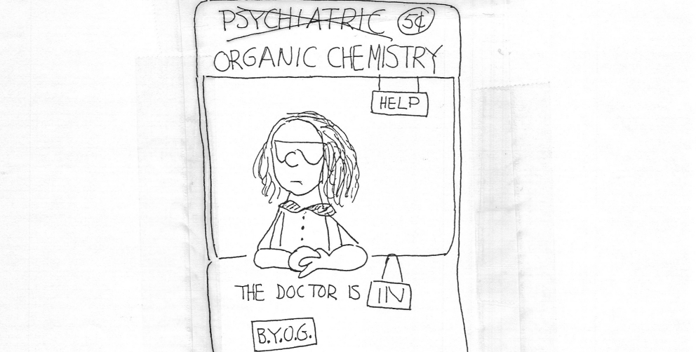* Bring Your Own Goggles By Se Young Um

FREE EXTENSION FORM

Name:
T.A.:
Section:
Name and number of lab to be submitted:
Date lab was carried out:
DATE LAB REPORT WILL BE SUBMITTED:
(this date can't be more than a week beyond official due date)

Signature:
Staple this form to the front of late report when you are turning it in. Form is not transferable to another student or another semester. If you have a late prelab only, please see your instructor.

SAFETY

Please view the safety videos linked into the schedule entry associated with this lab.

- You must wear the required safety goggles at all times while you are in the laboratory. There will be no exceptions. If a TA or an instructor finds you without goggles on, you will be reminded of the rule; after the first such reminder on a given afternoon the second instance of non-compliance with the rule on your part will lead to a reduction in your grade of 10 points for that experiment. Subsequent violations may result in your expulsion from the laboratory with no opportunity to make it up.
- Contact lenses can be very hazardous to wear in an organic chemistry laboratory; if you normally wear them, you might consider replacing them for laboratory use by regular prescription glasses. The required goggles are large enough to fit over regular glasses. If you are wearing contacts, you must wear goggles every second you are in the lab.
- You are required to wear nitrile gloves (purchased in bookstore) and aprons (provided in lab) for all labwork.
- Closed shoes (no flipfops)must be worn at all times in the laboratory. Sandals, flipflops and bare feet are prohibited.
- Avoid wearing shorts and new clothing in the lab.
- Long hair should be tied back while carrying out experiments.
- Smoking, eating, or drinking in the laboratory will not be permitted. You cannot bring water bottles or coffee into the lab.
- No unauthorized preparations or experiments may be attempted at any time.
- No unsupervised lab work is permitted.
- All lab work should be carried out in your assigned fume hood with the hood door down as far as possible.
- Avoid unstable assemblies of apparatus consisting of books, pencils, matchboxes, etc.
- When inserting glass tubing in a stopper, use a small amount of glycerine or vacuum grease as a lubricant and wrap both the stopper and the glass in a towel. Hold the glass tubing close to the point of entry into the stopper.
- Do not use cracked or chipped glassware; replace it.
- Never heat a closed system of any kind.
- NEVER EVAPORATE ETHER ON A HOT PLATE; use a hot water bath.
- Do not place highly volatile solvents in a beaker, even for short periods of time; use an Erlenmeyer flask with a cork. Beakers should be used only for solids and aqueous solutions.
- Wear goggles, gloves and aprons while washing glassware. Never wash glassware with hot water.
- Many organic substances are toxic or corrosive. Avoid inhalation of organic vapors or skin contact by organic substances.
- Keep the laboratory floors free of jackets, books, spilled ice, dropped stirring rods, stoppers, and pencils, and any other hazards that might cause someone to trip or slip.
- Keep your lab bench neat and orderly; a cluttered laboratory is a dangerous place in which to work.
- Advise your instructor of any health problems you have that may be aggravated by working in the organic lab, e.g., migraine headaches, allergies, etc.
- (WASHING GLASSWARE) Allow glassware to cool completely, then rinse it several times in the cup sink in the fume hood. Proceed to the normal sink. Wash (wearing gloves) with cold water and soap. Gradually increase the temperature of the rinse water. Rinse with acetone, then distilled water.

IN CASE OF ACCIDENT
The occurrence of an accident of any kind in the laboratory should be reported promptly to the instructor.

FIRE
Your first consideration is to remove yourself from any danger, not to extinguish the fire.

If your clothing is on fire, DO NOT RUN; rapid movement will only fan the flames. Roll on the floor to smother the fire and to help keep the flames away from your head. Your neighbors can help to extinguish the flames by using fire blankets, laboratory coats or other items that are immediately available. Do not hesitate to provide this aid if your neighbor is involved in such an emergency, since a few seconds delay may result in serious injury.

A laboratory safety shower can be used to extinguish burning clothing.
If burns are minor, immerse the affected area in ice water for a period of time. In case of serious burns, professional help should be sought at once. Report all accidents to your instructor.

CHEMICAL BURNS

Areas of the skin with which corrosive chemicals have come in contact should be washed immediately and thoroughly with water (fifteen minutes with cold water). This means that one should rinse the area involved for at least ten minutes with cold water. All injuries must be reported to the instructor. Be prepared to see a physician if you are instructed to do so.
Bromine burns can be particularly serious. These burns should first be washed with soap and water and then thoroughly soaked with saturated sodium thiosulfate solution for three hours. Be prepared to see a physician if you are instructed to do so.
If chemicals, particularly corrosive or hot reagents, come in contact with the eyes, hold eyes open and immediately flood with water from the specially designed eyewash fountain that is available in the laboratory. Do not touch the eye. The eyelid as well as the eyeball should be washed with water for 15 or more minutes. Be prepared to see a physician if you are instructed to do so.
Most of the organic chemicals you will encounter in this laboratory are not seriously corrosive, but many are at least mildly toxic. In the event you inadvertently get an organic chemical on your skin, it should be removed promptly by washing thoroughly with copious amounts of warm water and soap. The area should be rinsed for at least ten minutes with cold water. Do not use an organic solvent such as acetone or ethanol to remove chemicals from your skin.

CUTS

Minor cuts may be treated by first-aid procedures; seek professional medical attention for serious cuts. If severe bleeding indicates that an artery has been severed, attempt to stop the bleeding with compresses and pressure. Arrange for emergency room treatment at once.

Persons who are injured severely enough to require a doctor's treatment should be accompanied to the infirmary, even if they protest that they are all right and can make it on their own. Persons in shock, particularly after suffering burns, are often more seriously injured than they appear to be.

IN CASE OF EMERGENCY CALL SECURITY AT 911
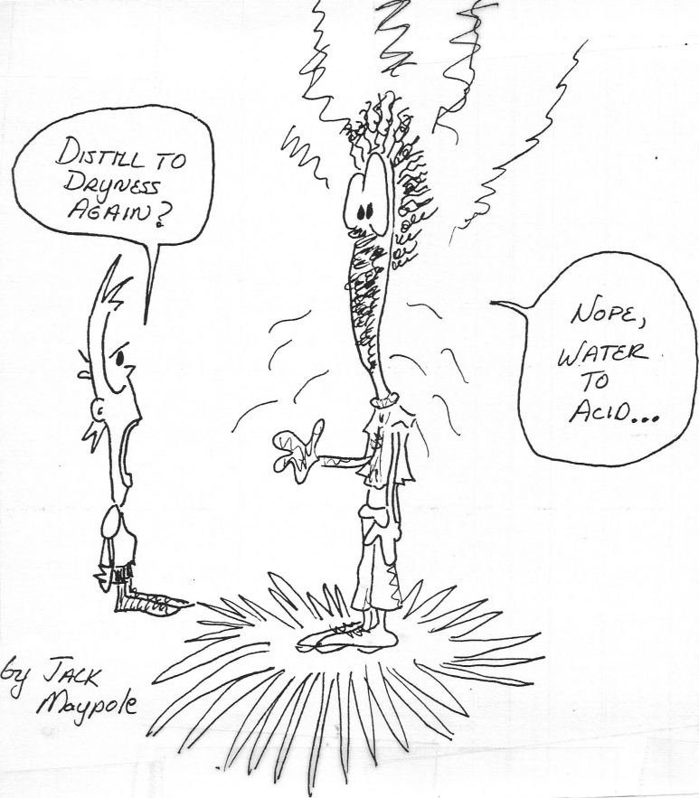

PROCEDURES

- It is critical for your success and your safety in carrying out the experiments in this course that you prepare yourself for each laboratory period by acquiring in advance a thorough understanding of the work to be undertaken in that period. The assigned Pre-Lab Exercises must be turned in to your TA immediately upon entering the lab. WHEN YOU WALK INTO THE LABORATORY, YOU SHOULD KNOW EXACTLY WHAT YOU ARE GOING TO DO AND WHY YOU ARE GOING TO DO IT. If you have any questions, ask your TA or instructor at the beginning of the period, during or after the pre-lab lecture. Without detailed advance planning, you may find yourself working too inefficiently to complete some of the more demanding experiments within the scheduled periods, and you may make mistakes that could lead to injuries to yourself or others in the laboratory. Be sure to check the marker board as soon as you come into the laboratory for last-minute instructions and/or helpful hints.
- There are many laboratory operations that require considerable time but little attention (e.g., refluxing a reaction mixture, allowing a sample to crystallize by cooling, allowing solvent to evaporate from a recrystallized sample, etc.). You should plan your work so that you use that slack time during these operations as effectively as possible by preparing for a subsequent step, taking a melting point from a previous experiment, making a label (perhaps with some blanks remaining to be filled in) for a sample to be submitted later, etc.
- All reagents needed for your experiments are in the dispensing areas in the laboratory. Liquids will be found in the two dispensing hoods and solids will be found near the balances. After you have used a reagent, return it to its proper place. DO NOT TAKE BOTTLES TO YOUR WORK AREA. Reagents with irritating vapors will be dispensed in a hood, and must be taken to your work area in a stoppered container.
- Liquids will generally be dispensed from bottles. When dispensing a liquid from a small bottle with a penny head stopper, remove the stopper from the bottle by gripping the penny head between your index finger and middle finger. While gripping the stopper in this way, lift the bottle using the same hand and pour. When dispensing liquids from a large bottle, unscrew the top and lay it on its back on the bench. Approximate the quantity of liquid needed by measuring it into a beaker. Then dispense the liquid from the beaker into a graduated cylinder. Can you guess the reasoning behind these procedures?
- Do not weigh samples directly on a balance pan; instead, use a tared piece of paper, a watch glass, a weighing boat, or a beaker as a container for the sample while it is being weighed.
- Clean up spilled chemicals immediately. Consult your TA if necessary.
- Do not throw waste or excess organic chemicals into a sink. Waste solvent containers will be provided. Always consult your T.A. or instructor before disposing of wastes!
- Do not put insoluble materials (including boiling stones, paper, and broken glass) in the sinks.
- Washing glassware. It is rarely desirable to wash glassware at the beginning of lab. In many experiments, you will work with water sensitive reagents. Very often that little bit of "crud" at the bottom of a flask is less harmful to a reaction than the water introduced by washing. Sometimes water is your enemy. When you do need to clean glassware, always wear gloves, goggles and an apron. A regular good general procedure for washing involves wiping all grease off with a paper towel and then washing the glassware using a brush/ soap and cool water (why cool?). After washing, the glassware can be rinsed with a small amount of acetone, followed by a rinse with distilled water. The glassware can be dried by baking it in the drying oven under your hood (watch out for plastic in the ovens - it melts). While this is a good general procedure, often times glassware does not require much attention. For example, If the only material coming in contact with the glassware is an organic solvent such as hexane, it is usually adequate to simply wipe the grease off and allow the glassware to air dry. If you are ever in doubt as to what to do, ask your TA or instructor. Believe it or not, unnecessary washing can cost you thirty to sixty minutes each lab period. Never wash hot glassware. If chemicals are particularly noxious or corrosive, rinse them several times in the cup sink in the hood with cold water.
- Before you leave the laboratory at the end of an afternoon, thoroughly clean your bench top with a sponge, and make sure that all of your vacuum, gas, and water connections are turned off and that all electrical equipment (hot plates, stir plates and power mites) are turned off, unplugged, and put away. Return all borrowed equipment. Put all equipment back where you found it.
Please leave the lab as you found it at the beginning of the lab period.

Working Greener
- Use the back pages of this manual for your lecture notes and for writing up reports.
- Try to print out spectra and data off the web only once.
- Recycle unused paper yourself or in appropriate containers.
- Only take the amount of reagent you require for a reaction.
- Dispose of and recycle chemicals as directed (ask if you don’t know)
- Use traps as directed.
- Do not allow the water to run continuously while washing.
- Reuse acetone when cleaning glassware.
- Recycle binder.
- Unplug equipment. Close you hood at end of the day or if you are not using it.

SUBMISSION OF SAMPLES

Most compounds that you prepare or isolate are to be turned in to your TA upon submitting the corresponding lab report. Unless instructed otherwise, it should be in a stoppered and labeled vial. The labels have been premade and are provided just inside the cover of this manual. Students should fill in all requested information on the label and attach it to vial.

Students are responsible for cleaning and recycling the vials upon receiving them back from the T.A.'s. Any supplemental data in the form of gas chromatography traces, infrared spectra, etc. should be submitted with your lab report.

++++++++++++++++++++++++++++++++++++++++++

...Every chemistry student, faced by almost any treatise, should be aware that on one of those pages, perhaps in a single line, formula, or word, his future is written in indecipherable characters, which, however, will become clear "afterward": after success, error, or guilt, victory or defeat...

So it happens, therefore, that every element says something to someone (something different to each) like the mountain valleys or beaches visited in youth. One must perhaps make an exception for carbon, because it says everything to everyone, that is, it is not specific, in the same way that Adam is not specific as an ancestor.

-- Primo Levi, The Periodic Table

CHECK-IN AND ORIENTATION

- Before coming to the laboratory, study all the pages preceding this one, paying particularly close attention to the material on safety.
- Meet your laboratory instructor and teaching assistants, and ask any questions you have about the course. Find your assigned locker.
- Using the locker lists and accompanying pictures given in the pages that follow, check-in your equipment. Consult your TA or instructor if you need help in identifying any items or if any of the equipment is missing or damaged and therefore needs replacing. Please note that equipment will be replaced free of charge ONLY DURING THE FIRST THREE WEEKS OF LAB. After that, you will be charged for any broken items. If any of your equipment is dirty, clean it with soap and water.
- Become familiar with the location of hardware, reagent shelves, hoods, distilled water, balances, melting point apparatus, gas chromatographs, infrared spectrometers, etc.
- Complete the following two forms, tear them out of your lab notebook and give them to your TA:
  - acknowledgment of receipt of equipment and understanding of safety rules
  - student information sheet

Organic Chemistry Lab

Acknowledgment
- I acknowledge that all of the equipment listed in the Locker List, Category A (see lab manual), is in my locker, and I agree to leave it in clean condition and to pay for the replacement of any items broken or lost.
- I have read and understand the Safety Rules and accident procedures given in the safety lecture and laboratory manual, and I agree to abide by them.

Signature: _____________________________________________________________

Name (printed):_________________________________________________________

Section (day and time):___________________________________________________
Teaching Assistant’s name:________________________________________________
Locker Number:_________________________________________________________
Date: ________________________________________________________________

Student Information Sheet
Chem 211/212
Name: Chem 211/212 Lab Day:
School (BMC, Haverford, Swarthmore, etc.):
Class ( ‘09, ’10, ’11, ’12, PB ) or other:
Where and when two semesters of General Chemistry were successfully completed:

Health conditions that lab staff should be aware of (e.g., migraines, epilepsy, Pregnancy, allergies, etc.):

Telephone numbers at school and at home:

Email address:

LOCKER LIST
Category A (Locker Drawer)

Beaker, 50 mL | 1.50
Beaker, 100 mL | 1.40
Beaker, 250 mL | 1.30
Beaker, 400 mL | 1.60
Beaker, 600 mL or 800 mL | 2.00
Cylinder, graduated, 10 mL | 2.10
Cylinder, graduated, 100 mL, with bumper | 2.90
Drying tube | 5.00
Flask (2), Erlenmeyer, 25 mL | 1.60 ea.
Flasks (2), Erlenmeyer, 50 mL | 1.60 ea.
Flasks (3), Erlenmeyer, 125 mL | 1.60 ea.
Flasks (2), Erlenmeyer, 250 mL | 2.00 ea.
Flask, filter, 125 mL | 6.40
Flask, filter, 250 mL | 6.40
Flask, round-bottomed, 24/40, 50 mL | 7.00
Flask, round-bottomed, 24/40, 100 mL | 7.00
Funnel, 5.1 cm, Buchner OR 7.8 cm Hirsh | 6.50
Funnel, 8.5 cm, Buchner | 13.40
Funnel, separatory, with stopper, 125 mL | 18.00 (28.00 with stopcock)
Funnel, separatory, with stopper, 250 mL | 21.50 (33.00 with stopcock)
Funnel, stemless, 5 cm | 1.00
Funnel, stemless, 7 cm | 1.50
Micro Distillation Kit** | 400.00 To be checked out as needed
Micro Vacuum kit *** | 60.00 To be checked out as needed
Pan, enamel OR plastic | 2.03
Spatula, nickel | 3.00
Stirring rod, glass, 20 cm. | 3.00
Test tubes (10), 16 x 150 mm | 0.30 ea.
Vials, 4 dram (6), with caps | 0.20 ea.
Watch glasses (2) | 1.00 ea.

**25mL round bottom flask
50 mL round bottom flask
100mL round bottom flask
100 mm West condenser
vacuum adapter
three yellow Keck clips
still head
2 septum caps
Claisen adapter
dropping funnel
*** micro Hirsh funnel
25 mL vacuum flask
Micro neoprene adapter
CATEGORY B (LOCKER DRAWER)
Adapter, filter, Neoprene, No. 2 or 3 | pH paper (1 vial)
Adapter, filter, black Neoprene, No. 4 | Pipettes (6), Pasteur
Adapter, thermometer, red Neoprene | Rubber bulb, 2 mL
Boiling stones, 1 vial | Test tube holder
Filter paper, 4.25 cm, No. 1, 1 pack | Weighing dishes (2)
Filter paper, 7 cm, 1 pack
Filter paper, 12.5 cm, No. 4
Rubber policeman

Category C (Green Cabinet)
Hot plate Stirplate

Category D ("F" Drawer)
Clamps 2 prong with holders (2)
Clamp 3 prong with holder (1)
Heating mantle (100 mL)
Heating mantle support
Iron Rings (1 large and 1 small)
Rubber tubing, black (2 pieces)
Rubber tubing, red (3 pieces)

Category E (small bin on bench)
Copper Wire
Grease
Rubber bands

Category F (cabinet under sink)
Acetone bottle Soap bottle
Wire brushes (1 large and 1 small)
PLEASE MAINTAIN YOUR AREA AS DESCRIBED ABOVE!

BREAKAGE AND LOSS

Do not remove equipment/glassware from other drawers

The glassware and equipment used in the is course is extremely expensive. The prices list on page G-27 are a fraction of the real cost. Please treat the glassware/equipment with Respect. Students are not charged for breakage in this course, but you should handle the equipment like you own it.
The equipment in Categories A and B should be stored in your locker and will only be used by you. The equipment in Category C will be stored in the cabinet under you hood and be shared by all those who work at your lab station. The equipment in category D will be stored in the "F" drawer at each stations and will be shared by all who work at your lab station. The equipment in Category E will be stored in special bins on the lab bench and the equipment in Category F will be stored in special crates under your sink and will be shared by all who use your sink. Realize that you will be sharing the sink and hood with someone else during your lab period. Because of this you will notice that the Category C and D equipment is duplicated in the oven cabinet and "F" drawer. One set is for you and the other for your neighbor. It is very important to return equipment to its proper location at the close of lab. Do not lock common equipment in your locker

"He says, you have to study and learn so that you can make up your own mind about history and everything else but you can’t make up an empty mind. Stock your mind, stock your mind. You might be poor, your shoes might be broken, but your mind is a palace."
— Frank McCourt (Angela's Ashes)

"It’s lovely to know that the world can’t interfere with the inside of your head."
— Frank McCourt (Angela's Ashes)

