**Experiment 3  
General Safety Considerations**

1. The solids in the unknown and methylene chloride (CH2Cl2) are toxic and irritating. Avoid all contact with them by working in the hood and wearing gloves and goggles. In the event of a major spill, contact your instructor.
2. The organics listed above are also flammable. Therefore, no open flames will be used in the laboratory. Do not overheat the CH2Cl2 solution at the beginning of the experiment. A low hotplate setting of one or two should be adequate since CH2Cl2 has a very low boiling point.
3. The aqueous HCI and NaOH solutions are extremely corrosive. Take all the precautions listed in step one above.
4. Vent your separatory funnel with each swirl. Your instructor will demonstrate this technique for you.
5. Do not extract a warm CH2Cl2 solution. Allow it to come to room temperature first. Why?
6. If you come in contact with any of the above listed chemicals, flush the exposed area for at least **fifteen minutes** using cold water.

**Chemistry 211-212 Investigative Experiments**

|  |  |  |
| --- | --- | --- |
| **Name** | **TA Name:** | |
| **Experiment** # **3** | **Lab Day:** | |
| **Unknown** # | | |
| Section 1 (Pre-lab) | | (25 points) |
| Section 2 (Results) | | (24 pts **a**, 10 pts **b**) |
| Section 3 (Post-lab questions) | | (50 points) |
| Quality of results | | (20 points) |
| TOTAL | | (119 points) |
| SCORE | | (percent) , |

**This is your report cover. Please fill it out and attach it to your pre-lab quest**

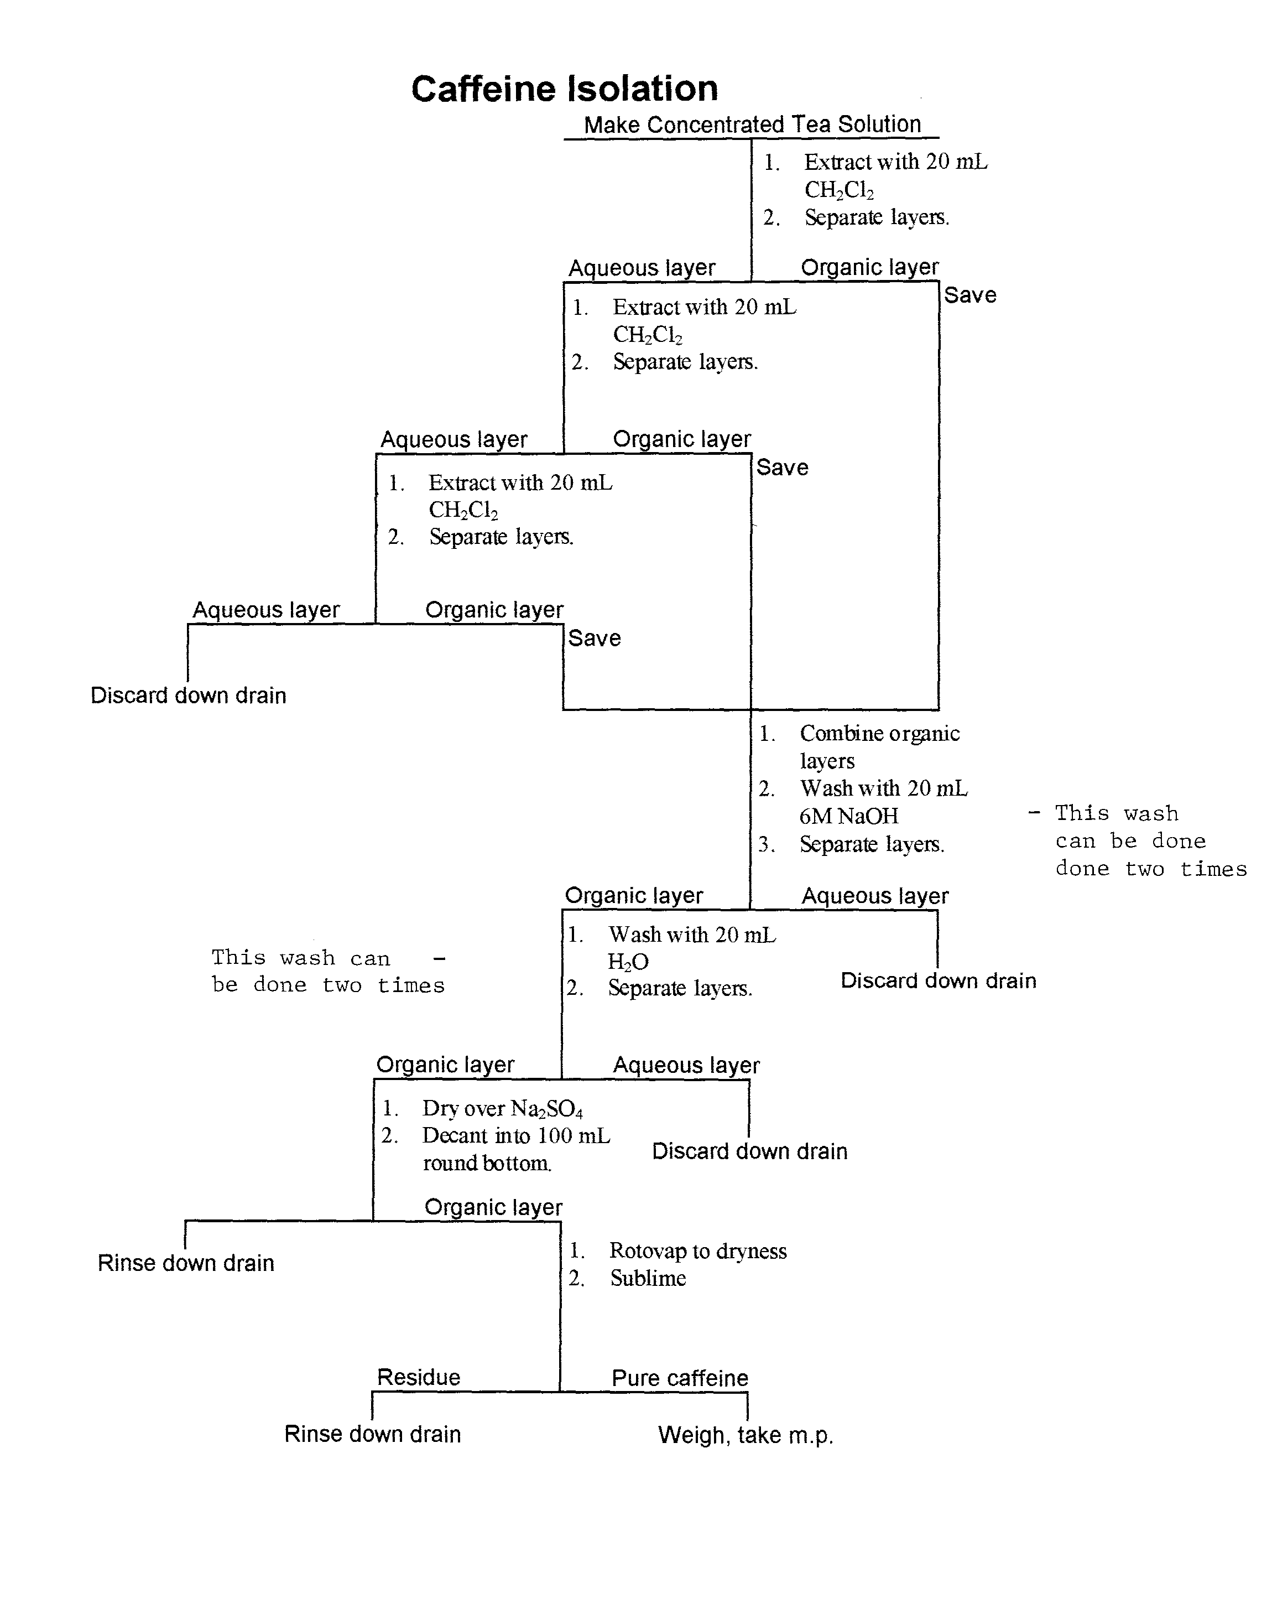

3-3

**Solubility and Drying Agents**

Generally speaking, organic liquids and solids are insoluble in water. This is because organic compounds are not as polar as water. To dissolve, a substance must be able to replace the favorable interactions it has with molecules like itself in the pure state with comparably favorable interactions from the solvent. If the predominant interactions are nonpolar and hydrophobic for a given organic compound, the organic molecules will not be able to find complimentary interactions in water which is polar and hydrophilic. Therefore, the organic compound will prefer to stay aggregated and segregated from the water. A good rule of thumb for predicting solubility in water is to assume that any molecule having six or more carbons and 0-1 functional group will be insoluble in water. Molecules having the described structural characteristics have physical properties that reflect the dominance of the hydrophobic hydrocarbon portion of the molecule.

When we predict that an organic compound is insoluble in water, that does not mean that one hundred percent of the compound will be insoluble in water. It means that enough of it will be insoluble so that two liquid layers or a significant precipitate will exist. Like most things, solubility is relative. So really, any time an organic compound comes in contact with water, some small amount of it will dissolve in the water and likewise, some small amount of water will end up in the organic. For an organic solid, the water can usually be removed by simply allowing the solid to air dry at atmospheric or some reduced pressure. Sometimes a low temperature oven can be employed to facilitate drying. The high vapor pressures of most liquids preclude the use of any of the described methods for the removal of water.

When an organic liquid has been exposed to water, a drying agent is frequently utilized. A drying agent is typically an insoluble, inorganic salt that hydrates upon exposure to water. Molecules that make hydrates have cavities in their molecular structure that will accommodate a certain number of water molecules. For example, if sodium sulfate (Na2SO4) is exposed to water it will form hydrates having the general formula Na2SO4 nH20. Given enough time and enough drying agent, all the water in a contaminated organic layer can be incorporated into the inorganic salt. When the water is absorbed into the inorganic compound, the salt retains its solid state and can be removed by decanting or gravity filtration. The drying agent can be regenerated by heating it to a high temperature.

Listed below are a few drying agents that are commonly used by organic chemists. Organic liquids are considered to be wet if they contain water. Realize that the organic liquid will still be a liquid after it is dried.

**Magnesium Sulfate:** Magnesium sulfate is a great drying agent. It has a high capacity, is complete in its drying and is rapid. Capacity refers to how much water per gram the drying agent holds and complete means that drying equilibrium favors the hydrate. The only disadvantages to using magnesium sulfate is that it is only available in a powder form and must be filtered out. More importantly, magnesium is a very strong Lewis acid and as such, is not inert to all functional groups. For example, epoxides are sensitive to magnesium.

**Sodium Sulfate:** Sodium Sulfate is the most widely used drying agent. It is very similar to magnesium sulfate in its capacity, but it is less complete ( will leave more water in solution) and it is slower in terms of its rate. Sodium sulfate has the advantage in that it is less reactive and in granular form, is very easy to remove from liquids. The liquid can often be decanted off the drying agent without filtration.

**Calcium Sulfate:** Calcium sulfate is known by the trade name drierite. Calcium sulfate has a low capacity, but it is very complete and rapid. This means that you will have to use more of it to dry a solution. Calcium sulfate can be purchased in a chunky form. This form is very convenient to work with. It is also used as a drying agent in dessicators and to dry the air entering a water sensitive reaction. The drierite can be obtained in a dyed form. The dye functions as an indicator of how much water has been absorbed. The dyed form is not suitable for use as a drying agent for liquids. Why?

**Calcium Chloride:** Calcium chloride is very much like calcium sulfate except that it will also absorb methanol and ethanol.

**Potassium Carbonate:** Potassium carbonate is basic and as such, is generally used in basic media. It is of average capacity, completeness and rate.

**Some Practical Advice**

At this point it is important to reiterate that when you add a drying agent to a solution, it will just sit on the bottom of the container because it is an insoluble solid. The problem with drying agents is there is a tendency to add to much. So how much is enough? It is best to start conservatively. Add a spatula tip and then swirl. After the drying agent has settled, observe the solution. If the solution is transparent that is a good sign that you are close to the end point of addition. If the solution is cloudy, you probably need to add more in small increments. Once the solution begins to appear to be clear, study the drying agent itself. Does it look all clumpy or is it freely flowing? In other words, does it look the same as when you first added it? Drying agents clump and stick to the bottom of the vessel as they pick up water, so if the agent looks really clumpy and sticky, you need to add more. Continue to add drying agent until the newly added material appears unchanged and free flowing. Recognize the originally clumped material will never unclump.

Why be so cautious? Why not just add a “whole mess” of drying agent? I can assure you that it has been done before and hey, if some is good, more is better. This is definitely not the part of the procedure where you want to adopt a hedonistic philosophy. If you add excessive drying agent, you will lose a lot of your desired liquid upon isolation. Think about it, a finite amount of liquid will adhere to the surface of the drying agent. If you use copious quantities of drying agent , you will lose large amounts of the desired compound.

3-5

**Rotary Evaporation**

In this laboratory you will use rotary evaporation to isolate eugenol and caffeine. It is easiest to understand rotary evaporation if you recognize that it is really just a fancy type of distillation. In this experiment, you will want to remove methylene chloride from caffeine and eugenol. Since methylene chloride is much more volatile (b.p. ca. 40 °C) than either of the solutes, distillation is the textbook way to achieve the separation. The problem with conventional distillation is that it can take a long time, compounds are not infinitely stable to the high level of heat applied and one can't distill to dryness when attempting to isolate a solid.

Several concepts can be employed to facilitate the removal of a volatile solvent from a solid. Working at reduced pressure is very useful because atmospheric pressure and boiling points are related. In principle, if the pressure is low enough, the volatile component will boil at or below room temperature. In addition to speeding up the process, working at room temperature can eliminate the need for heat. Since explosive peroxides are more likely to form at elevated temperatures, one can pretty safely distill to dryness at reduced pressure. Another useful alteration to conventional distillation is to have the pot rotate during the solvent removal. When the pot is oriented at an angle and is rotated, the solvent continuously coats the surface of the flask, increasing the surface area and the rate of evaporation.

The rotary evaporation apparatus (AKA "rotavap") incorporates all of the above features. The sample is placed in a round bottom that is attached to an angled steam duct which has the capability of rotation. This steam duct connects the round bottom to the rest of the still which consists of a very elaborate condenser and a receiver. The still is hooked up to a vacuum system of some sort. In our lab, the vacuum systems are simple aspirators. An aspirator is a metal or plastic tube linked to a water faucet. The tube has a side outlet which is attached via vacuum tubing to the rotavap. When the faucet is turned on, the water creates a vacuum as is rushes past the side opening, creating a vacuum. After the flask is attached to the steam duct, evacuation is begun and the still pot is immersed in a low temperature water bath. At this point, the rotor is turned on and the flask begins to spin. Once again, the rotation increases surface area and the reduced pressure lowers the boiling point. In this way, solvents can exhaustively be removed from a solid or nonvolatile liquid.

It is hoped from this brief discussion, that it is fairly obvious why this technique is reserved for the isolation of nonvolatile liquids and solids. What would happen if you attempted to do a fractional distillation of two volatile liquids using a rotavap? Why is it not prudent to isolate a pure solvent using this method?

Please view the youtube about this technique that is linked into our schedule on the webpage.

**Practical Considerations....**

1. Attach the sample to the steam duct and use a clip to secure the flask.
2. Begin evacuation by turning the stopcock to an orientation that is perpendicular to the stopcock opening.
3. Turn the rotation mechanism on.
4. Release the jack and lower the sample into the bath.
5. When all the sample has been removed, reverse all the above procedures. Start with step 4 and work your way back to step 1.
6. It is very important to allow the pressure to equalize before attempting to remove the flask. When you release the vacuum you will hear the rush of air entering the rotary evaporation apparatus. The sound will start out very loud and become lower and lower. When the sound

becomes level, the pressure has equalized. To remove the flask, use the black piece on the steam duct. Rotate it down until it pushes your flask off. This will take the flask off in a very smooth manner, reducing the likelihood that the sample contents will bump into the steam duct.

**Experiment 3**

**Extraction**

Extraction is a separation technique that depends on differential solubility in a chosen solvent. Extraction is most appropriately applied when a desired compound exists in a matrix that consists of several other components. These other components can be viewed as contaminants in this context. This matrix can either be solid or liquid. In the most general sense, the matrix is exposed to a solvent which is chosen because of its selectivity in terms of solubility for the desired compound. The solvent must also be relatively volatile and inert. Why? After an appropriate period of interaction, the newly formed solution is removed, leaving the balance of the matrix behind. The solvent is then separated from the desired compound, often by distillation or rotary evaporation. Sometimes extraction is used to specifically remove contaminant molecules. In this circumstance, the extraction is called a "wash" though all the same principles apply.

If the matrix is solid state, the process is called solid/liquid extraction. For example, you carry out a solid/liquid extraction every time you make a cup of coffee or tea at home. The coffee or tea constitutes the solid matrix and the hot water serves to remove molecules from the matrix. Making such a hot beverage is not particularly selective since many different molecules are removed from the solid matrix. For example, if you make a cup of tea, you are extracting xanthines [ caffeine (5 % by weight of the tea), theophylline, and theobromine], tannins (phenolic compounds having molecular weights between 500-3000) , flavinoid pigments and chlorophyll among other compounds. The flavinoids and chlorophyll give the tea its characteristic color. Tea leaves are predominantly cellulose. Since cellulose is water insoluble, it is remains in the solid matrix after extraction.

If you want to selectively remove individual components of the tea solution, a series of liquid/liquid extractions can be employed. The xanthines can be isolated by extraction with methylene chloride and the tannins can be extracted using aqueous base.

Liquid/liquid extractions involve the partitioning of a substance between two immiscible layers. When the extraction or wash layer comes into contact with the original layer, the molecules begin to commute between the two layers. They will continue to have a net migration into the extraction layer until a steady state or equilibrium is established. The relative numbers of molecules in each layer is directly related to the solubility of the molecules in each of the two immiscible solvents, i.e., more of the desired compound will dissolve in the layer in which it is more soluble. The relative solubility of a solute in two different immiscible solvents can be described using the Nernst distribution law.

**Nernst Distribution Law:**

|  |  |
| --- | --- |
| Kp = | solubility of solute in solvent 1 |
| solubility of solute in solvent 2 |

The solubilities are reported in units of grams/mL. The solvent in the numerator is the solvent in which the solute is most soluble. Kp varies with changes in solute, solvents and temperature.

The following example delineates one use of this law . The type of extraction outlined in this example is analogous to the sort of extraction used to decaffeinate tea or coffee.

**PROBLEM:**

400 mL of a solution of aniline in H2O (.125 mg/mL) is extracted with 50 mL of ether. The distribution coefficient or partition coefficient (Kp) for aniline (ether/H20) = 3.5.

How much aniline will be extracted into the ether layer?? **SOLUTION:**

Calculate mass in 400 mL of the aqueous solution. 0.125 mg/mL (400 mL) = 50 mg

Before contact between layers:

0 mg of aniline in 50 mL ether

50 mg of aniline in 400 mL H2O

After contact/equilibration

x mg of aniline in 50 mL ether

(50-x) mg of aniline in 400 mL H2O

Therefore, according to **Nernst Law:**

|  |  |
| --- | --- |
| Kp = 3.5= | x/50 |
| 50-x/400 |

|  |  |
| --- | --- |
| 3.5= | 400x |
| 50(50-x) |

|  |  |
| --- | --- |
| 3.5= | 400x |
| 2500- 50x) |

|  |  |
| --- | --- |
| x= | 15.2 mg |

Another term that arises occasionally in the context of extraction is "backwash". A backwash is used when a washing step has resulted in the undesired extraction of the compound being isolated. To recover the lost compound, one extracts the wash layer with fresh solvent identical to the solvent originally holding the compound. This "backwash" is recombined with the original solution.

Some of the extractions described in this experiment take advantage of the fact that one or more of the substances being separated have acidic or basic properties. For example, tannins are acidic compounds. Such chemically reactive compounds can be converted into their corresponding conjugate form which will be much more soluble in an aqueous extraction layer. Once separated, each compound can be chemically converted to the original form if desired.

To understand this concept better, consider what would happen if a solution of p­chloroaniline and benzoic acid in methylene chloride was extracted with water. Since these two organic compounds are much more soluble in methylene chloride ["like dissolves like" - usually organic compounds with 6 or more carbons and one functional group are much more soluble in organic solvents than water (see manual appendix)], most of the molecules would stay in the organic layer and a few would enter the aqueous layer as depicted below schematically.

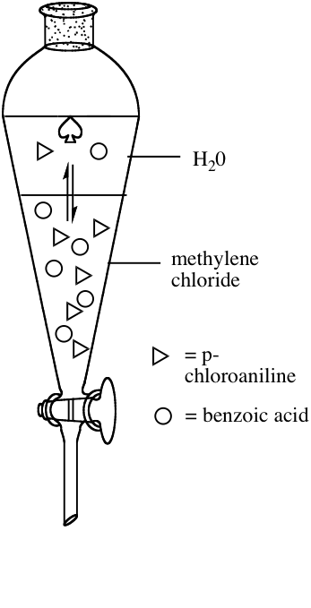

Now consider what would happen if the same methylene chloride solution was extracted with aqueous HCl, a strong acid. Obviously, benzoic acid is an acid. Less obviously, p-chloroaniline is a base and this base should react with the acid. The following scheme diagrams the equilibria involved.

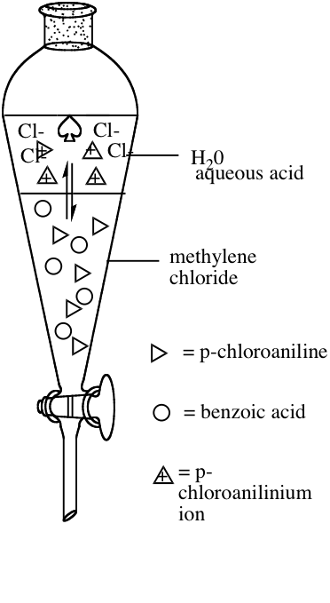

What I have attempted to depict is that initially, a few molecules of each species migrate across the barrier into the polar, aqueous layer. Realize that molecules are also passing back into the organic layer, the equilibrium greatly favoring the organic layer. Benzoic acid happily does this and is not effectively extracted out, but p-chloroaniline (the base) encounters hydronium ion in the aqueous medium and undergoes the following reaction.

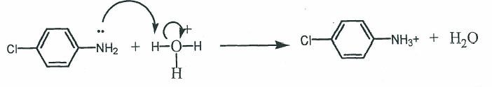

Please make note of the arrow formalism. Ask your instructor if you do not understand it. Please see the youtube videos on this subjected linked into the schedule on the web page. Gerenally, what you are doing is showing proton transfers from the perspective of the electrons. In arrow formalism, you draw an arrow from the electrons that receive the proton to the proton being transferred and you then release the electrons on the other side, by drawing an arrow from the electrons bonded to the proton to the new atom that will bear the negative charge. These arrows are only drawn from electrons to atoms and from bonds to atoms. Never start an arrow at an atom. You will need this tool on and off for the rest of the course.

The p-chloroanilinium chloride formed is an ionic compound and as such, is extremely soluble in water. The complete conversion of p-chloroaniline into the highly soluble p-chloroanilinium chloride puts a stress on the water/methylene chloride p¬chloroaniline equilibrium. What do you predict happens? To answer this question you need to think about LeChatlier's Principle.

The described process results in the isolation of p-chloroanilinium chloride. Since the desired compound is p-chloroaniline, a chemical transformation is indicated. The isolated salt can be converted back to the corresponding conjugate base by treatment with base as shown in the following reaction. Since the conjugate base is a neutral, organic solid, it readily precipitates out of the aqueous solution.

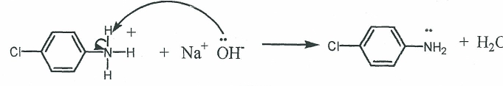

With the above background in hand, think about the chemistry involved in the isolation of benzoic acid. Be prepared to discuss this in pre-lab lecture.

In preparation for lab this week, be sure to do all the readings associated with this lab and the prelab questions below. You will be extracting caffeine from tea. The procedure is given below.

1. What is the difference between extracting and washing? (4 points)

2. Can you think of three ways to distinguish the layers during an extraction  
(Hint: think about densities, solubility in water, color, volume)? (6 points)

3. What is back-extraction (backwash)? (2 points)

4. Look up the structures of caffeine, theobromine and theophylline. Write their structures and describe their biological activities (medical use) . ***The Merck Index*** is a good source of this sort of information. You might also try some of the links given on the Chem 211/212 website,e.g., **NIST** or **Cambridge** or just use **Wiki** or **Google**. (8 points)

5. What is sublimation? (a simple definition will suffice) (5 points)

Please note again, you will only be assigned one of the two following procedures. To find out your assignment check the web site schedule.

# Extraction of Caffeine from Tea

A flowchart for this experiment on page 3-3

## Procedure:

1. Obtain four tea bags and note the net mass of tea in each bag (this can be obtained from the tea box).
2. In a 250 mL beaker, heat 100 mL of distilled water to just below boiling (97-99 °C).
3. Swirl the tea bags in this water for several minutes.
4. Remove the excess water from the bags by squeezing the bags between two watch glasses and allowing the tea to return to the beaker.
5. Allow the tea solution to cool to room temperature (this cooling can C be accelerated using an ice bath.
6. Pour the tea solution into a 250 mL extraction funnel.
7. Add 20 mL of methylene chloride (dichloromethane) and using the swirling technique demonstrated by your instructor (you can also watch the youtube on extraction that is linked into this website), extract the caffeine from the tea solution.  
   It is very common for this particular extraction to form an emulsion upon swirling. Emulsions are good in a way because they provide intimate, extensive and lengthy contact between the layer (faster equilibration — more effective transfer of molecules). Unfortunately though, they are difficult to separate. It has been determined that it is best to try to separate the emulsion mechanically (gentle stirring of the mixture with gradual drainage of any separated lower layer). If this does not work, add a few spatula tips of sodium chloride to the mixture and gently swirl. How do you think the sodium chloride works to break up the emulsion?
8. Separate the layers, carefully storing the organic layer in a covered Erlenmeyer.
9. Re-extract the aqueous layer two more times with 20 mL portions of methylene chloride. Collect all organic layers in the same vessel.
10. Take the combined organic layers and wash it with two successive 20 mL portions of 6 M NaOH (use care – corrosive) and then one 20 mL portion of distilled water. Please note that washing is also extracting – it is the same technique. This term is used when a contaminant is being removed. Which contaminants are being removed in each of these washes?  
    It is not uncommon for beginning students to mix up layers – very common actually.
11. Take the combined layers and add an appropriate amount of anhydrous sodium sulfate to "dry" the solution. Add the drying agent in small increments. The goal is to add enough so that the solution looks transparent and that there is some free flowing sodium sulfate (sodium sulfate that is not clumped up from hydration).
12. Decant the solution into a tared, 100 mL round-bottomed flask and rotovap the solution to dryness. Your instructor or TA will demonstrate the use of the rotary evaporators.  
    You will know you are done when you see a greenish-white shell of solid on the inside of the flask and it appears dry.
13. Measure the mass of this flask and determine the mass of the crude caffeine.
14. Using a spatula, vigorously and thoroughly scrape the caffeine out of the round-bottom and into a 125 mL vacuum flask.
15. Equip the flask for sublimation with a neoprene adaptor, a test tube filled with dry ice and coated with a small strip of parafilm, supported on a hot plate as described in detail in the youtube linked to our schedule on the web page.
16. Double check to see that the test tube is dry (watch out for condensation – very bad). 17.
17. Begin heating at a moderate setting. It is lots of fun to watch the sublimation!!! Stop heating when there is no more white material on the bottom of the flask. If you have succeeded there should be a significant amount of very pure, white caffeine deposed on the test tube.
18. Place the entire apparatus in your locker and allow the dry ice to sublime out of the apparatus. Come back in the next two days. By doing this, you will find that your caffeine is nice and dry and you will be able to scrape the pure caffeine off the apparatus onto or into a tared container. Obtain mass and melting point. Calculate the percent recovery (percent recovery = Mass of caffeine obtained/mass of tea extracted * 100).

## General Comments on Making Melting Point Measurements

Please see video on how to use a meltemp apparatus linked into this laboratory.

1. Densely pack the capillaries (using the packing tubes) to a maximum height of 2 mm. Use a ruler if you have not have a good sense of the metric system.
2. Generally, the samples will shrink and expel recrystallization solvent first (sweat). Then they will begin to melt. You can either first record the temperature at which liquid is first observed at the bottom of the tube or the shrinkage/sweat point. The liquid at the bottom temperature is more traditional, but this is difficult to judge in some cases. The second temperature to be recorded is the temperature at which all the solid is liquid.
3. Set the mel-temp voltages to a level that provides a temperature change of 20/minute. To determine this, consult the voltage charts provided at the melting point stations.
4. Efficiency Tips: The mel-temps do not have to cool to room temperature to start a new measurement. They must, however, be cooled to approximately ten degrees below the projected starting melting temperature of the next sample. When the block temperature is excessively low, the voltage can be set higher than desired until you get within ten degrees of the projected melting temperature to speed up the heating of the block. Once you are within ten degrees, however, reset the voltage to an appropriate value.
5. Your instructor will be delighted to help you with any questions/problems you may have. Please bother her! Don't beat your head against the wall!

**Vacuum Filtration Apparatus**

**Put in picture**

## Lab Report

**Your lab report should include the following. Once again this will not be an investigative or preparative lab per se. Just include the items listed below.**

1. The answers to all the pre lab questions. (25 points)
2. All your raw and processed data. For the caffeine extraction, you need to include the mass of caffeine extracted (2 points) , the melting point range of the caffeine (4 points) and the percent recovery of the caffeine (4 points). The percent recovery does not take into account the theoretical amount of caffeine it tea. It is simply the mass of caffeine isolated divided by the mass of tea used in the original extraction multiplied by 100.  
   If you do the other acid/base procedure, you need to include the masses of the two compounds (4 points) , their melting point ranges (8 points) and the percent recovery of each (8 points) . You also need to calculate the percent composition of the unknown (4 points). The percent compositon is the mass of each component divided by the total mass recovered multiplied by one hundred. This is done for each component.
3. Answer all of the following questions in your notebook.
   1. Write an arrow formalism leading to products for each of the following reactions. If you do not think the reaction will occur write "no reaction". ( 8 points)

a)

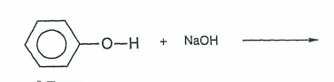

b)

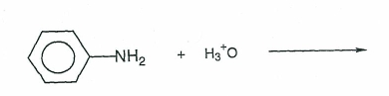

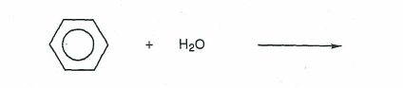 c)

1. Stronger acids such as benzoic acid are often extracted with sodium bicarbonate (NaHCO3). (8 points)
   1. Write a proper Lewis structure for NaHCO3.
   2. Using the proper Lewis structure above, write an arrow formalism for the following reaction. You only need to write the arrows for the Bronsted acid/base reaction.

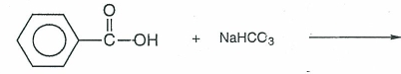

* 1. Explain why hissing and fizzing is always observed when NaHCO3 is used (Hint: NaHCO3 *is baking soda*).

1. 250 mg of caffeine are dissolved in 400 mL of water. Two extractions are carried out using 20 mL of methylene chloride each time. Given the information that Kp = 3.0 for this extraction at room temperature, how much caffeine will be extracted? How does this number compare to one single extraction with 40 mL of methylene chloride? (10 points)
2. Go through the procedure thoroughly and list all the places where you definitely lost caffeine. Indicate where you feel you lost the most material. (10 points)
3. How do you know you have the right compound. Comment on the reliability of your structural proof. What information do you have that tells you that you have caffeine? (8 points)
4. Before answering the following question, please note that when a solid is contaminated, the melting point is normally depressed and broadened. Because of this, melting points can be used to roughly ascertain purity as well as identity.  
   If your melting point is less than perfect, what do you think are the most likely contaminants to your compound? (6 points)

*******************************************************

[Hydrochloric acid] is one of those frank enemies that come at you shouting from a distance, and from which it is therefore easy to protect yourself. It has such a penetrating odor that whoever can wastes no time in getting out of its way; and you cannot mistake it for anything else, because after having taken in one breath of it you expel from your nose two short plumes of white smoke, like the horses in Eisenstein's movies, and you feel your teeth turn sour in your mouth, as when you have bitten into a lemon.

-- Primo Levi, *The Periodic Table*

*******************************************************

# Sample Discussion

The following is an acceptable discussion that would be appropriate for lab 2a. Please compare what you wrote in your question answers with this and try to improve your writing style and the level of detail that you are incorporating into your answers.

Please note that this discussion includes the errors that occurred for everyone doing the lab. Also note that the discussion is written in the third person, passive voice and that a serious effort is made to avoid repeating data that was given earlier in the lab report.

As you evolve toward writing full discussions, please consider the following. Though I am looking for good content, I want you to write your reports in the most efficient way possible. For many students, hand writing is the quickest way to write the reports. Unfortunately, some students feel "married" to their hand written work. This means that they will not change a passage even if they have written incorrect statements. As stated earlier in the course, it is okay to cross out and rewrite sections provided the writing is legible. Ideally, word processing the sections where there is a lot of writing would be the fastest for most students. I think these days most people can type faster than they write. The only problem with word processing is that there is a tendency to write very elaborate, formal reports, i.e., to get carried away. If this is your tendency, you might want to avoid this method. Also, it is important to remember that even if you choose to word process, you still have to record your data in your lab notebook while carrying out the experiments. People who word process tend to get in that nasty habit of writing crucial data on scraps of paper. Finally, while our ultimate goal is to write concise, clear paragraphs that describe relevant chemical phenomena at a molecular level, initially, many students do better to write answers and discussions in a list format as demonstrated in part of the following discussion. Lists frequently are closer to scientific writing than the typical first attempts at full paragraphs.

## Identity

For this experiment, very limited data was collected to establish identity. For each compound, the appearance and melting point ranges are the only relevant information. The melting point range of the isolated benzoic acid exactly matched the literature melting point range as given in the results section of this report. The isolated solid was a white, crystalline material and this is consistent with the literature description of benzoic acid.'

p-Chloroaniline had a slightly depressed and broadened melting point as compared with the literature as indicated in the results section of this report. The literature describes p-chloroaniline as a white, crystalline solid. The isolated material was a beige, crystalline solid. The slight discrepancies in the data for this compound make the identification less certain, but it is consistent enough to assume that the isolated material was predominantly the desired compound.

## Yield

As indicated in the results section of this report, considerable material was not recovered in this purification. The following is a description of where losses generally occurred for pchloroaniline and benzoic acid.

1. After dissolving the crude material in methylene chloride, it was transferred to a separatory funnel. There was significant residue on the flask that originally held the solution and it was not recovered completely.
2. Since extractions involve equilibria, they are seldom one hundred percent effective. In each extraction, some of the desired compound was left behind in the organic layer resulting in a reduced yield.
3. In each extraction, some of the aqueous layer was left behind in the separatory funnel when transferring it to the collection flask.
4. Each of the two desired compounds has a finite solubility in water. Therefore, some will remain in the mother liquor after neutralization is achieved and will be lost upon vacuum filtration.
5. Significant quantities of each of the two desired products was lost upon transfer from the precipitation flask to the Buchner funnel when carrying out the vacuum filtration.
6. Due to the finite solubility of each of the compounds in water, some of each was lost when the filter cake was rinsed with water while in the Buchner funnel.
7. Material was lost when the solid was transferred from the Buchner funnel to the watch glass.

## Percent Composition

The following errors contributed to loss of more of one compound than the other, resulting in an inaccurate ratio. Since the percent composition was an unknown, the following errors are somewhat speculative. All errors listed would result in a disproportionate loss of p-chloroan iline.

1. p-chloroaniline was extracted first and the technique used to carry out the extraction was somewhat tentative (meaning first extractions by novices tend to be less vigorous) resulting in a lower surface area between the layers and less equilibration time.
2. p-Chloroaniline tends to oil out. This means that as a low melting solid, there is the possibility that it will separate out as a liquid rather a solid. This would happen if there was enough contaminant present to depress the melting point significantly. If any of the material separated as an oil, it would be lost during the vacuum filtration step.
3. Since a relatively small amount of p-chloroaniline was isolated, it is reasonable to assume that the unknown had less p-chloroaniline. Since the same sized glassware was used for each isolation, a higher percentage of p-chloroaniline may have been lost during the various transfers.

## Purity

As given in the results section, the experimental melting point of the isolated benzoic acid compared very favorably with the literature melting point, whereas the melting point of the isolated p-chloroaniline was somewhat depressed and broadened. 1 Since the benzoic acid was highly pure there will be no discussion of purity or speculation about contaminants in this discussion.

The p-chloroaniline was slightly contaminated. Since spectral and chromatographic analysis were not carried out on the products, the contaminants) cannot be specifically identified. The most likely contaminants are those that came into contact with the sample. These are methylene chloride, water, benzoic acid, sodium chloride and sodium hydroxide. The presence of ionic compounds (NaCI, NaOH) would be obvious in the melting point measurement, in that some of the sample would not melt until a very high temperature. Since this melting behavior was not observed, it was concluded that significant amounts of sodium chloride and sodium hydroxide were not present. Benzoic acid is a likely contaminant because it was present in the methylene chloride during the extraction of p-chloroaniline, Not only could it have dissolved slightly in the aqueous extract, but it is common for an aqueous layer to be slightly contaminated with the organic layer after separation. Since there was plenty of benzoic acid in the organic layer, contamination with organic also means contamination of the desired compound with benzoic acid. This explanation also outlines how methylene chloride could come to be in the sample. The water would come from the crystal growth and subsequent rinsing during vacuum filtration. Since the crystals were grown in an aqueous environment, water can get trapped inside crystals. If the crystals were not totally dried on the vacuum, the water clinging to the crystals could result in a depression and broadening.

' CRC Handbook of Chemistry and Physics, 58th Edition.

What I have attempted to depict is that initially, a few molecules of each species migrate across the barrier into the polar, aqueous layer. Realize that molecules are also passing back into the organic layer, the equilibrium greatly favoring the organic layer. Benzoic acid happily does this and is not effectively extracted out, but p­chloroaniline (the base) encounters hydronium ion in the aqueous medium and undergoes the following reaction.

3-11

Please make note of the arrow formalism. Ask your instructor if you do not understand it. You will need this tool on and off for the rest of the course. The p-chloroanilinium chloride formed is an ionic compound and as such, is extremely soluble in water. The complete conversion of p-chloroaniline into the highly soluble p-chloroanilinium chloride puts a stress on the water/methylene chloride p-chloroaniline equilibrium. What do you predict happens? To answer this question you need to think about LeChatlier's Principle.

The described process results in the isolation of p-chloroanilinium chloride. Since the desired compound is p-chloroaniline, a chemical transformation is indicated. The isolated salt can be converted back to the corresponding conjugate base by treatment with base as shown in the following reaction. Since the conjugate base is a neutral, organic solid, it readily precipitates out of the aqueous solution.

3-12

With the above background in hand, think about the chemistry involved in the isolation of benzoic acid. Be prepared to discuss this in pre-lab lecture.

In preparation for lab this week, be sure to do all the readings associated with this lab and the prelab questions below. You will be extracting caffeine from tea The procedure can be obtained via a link on the Chem 211/212 website

***Prelab Questions:***

1. What is the difference between extracting and washing? (4 points)
2. Can you think of three ways to distinguish the layers during an extraction (Hint: think about densities, solubility in water, color, volume )? (6 points)
3. What is back-extraction (backwash)? (2 points)
4. Look up the structures of caffeine, theobromine and theophylline. Write their structures and describe their biological activities. ***The Merck Index*** *is* a good source of this sort of information. You might also try some of the links given on the Chem 211/212 website,e.g., NIST or Cambridge. (8 points)
5. What is sublimation? (5 points)

Please note again, you will only be assigned one of the two following procedures. To find out your assignment check the web site schedule.

**Procedure: Extraction of Caffeine from Tea**

Procedure can be obtained from the Chem 211/212 web site. A flow chart for this experiment can be found at the beginning of this lab. ***www.brynmawredu/Acads/Chem/mnerzato/index.htmi***

**Extraction of Caffeine from Teal**

*By Maryellen Nerz-Stormes*

**Procedure:**

1. Obtain four tea bags and note the net mass of tea in each bag (this can be obtained from the tea box).
2. In a 250 mL beaker, heat 100 mL of distilled water to just below boiling (97-99 °C).
3. Swirl the tea bags in this water for several minutes.
4. Remove the excess water from the bags by squeezing the bags between two watch glasses and allowing the tea to return to the beaker.
5. Allow the tea solution to cool to room temperature (this cooling can be accelerated using an ice bath.
6. Pour the tea solution into a 250 mL extraction funnel.
7. Add 20 mL of methylene chloride (dichloromethane) and using the swirling technique demonstrated by your instructor or TA, extract the caffeine from the tea solution.

It is very common for this particular extraction to form an emulsion upon swirling. Emulsions are good in a way because they provide intimate, extensive and lengthy contact between the layer (faster equilibration — more effective transfer of molecules). Unfortunately though, they are difficult to separate. It has been determined that it is best to try to separate the emulsion mechanically (gentle stirring of the mixture with gradual drainage of any separated lower layer). If this does not work, add a few spatula tips of sodium chloride to the mixture and gently swirl. How do you think the sodium chloride works to break up the emulsion?

1. Separate the layers, carefully storing the organic layer in a covered Erlenmeyer
2. Re-extract the aqueous layer two more times with 20 mL portions of methylene chloride. Collect all organic layers in the same vessel.

*3—12a*

1. Take the combined organic layers and wash it with two successive 20 mL portions of 6 M NaOH (use care – corrosive) and then one 20 mL portion of distilled water. Please note that washing is also extracting – it is the same technique. This term is used when a contaminant is being removed. Which contaminants are being removed in each of these washes?

It is not uncommon for beginning students to mix up layers – very common actually. **Just remember you can always salvage your isolation if you save all layers. Do not throw anything away.**

1. Take the combined layers and add an appropriate amount of anhydrous sodium sulfate to "dry" the solution. Add the drying agent in small increments. The goal is to add enough so that the solution looks transparent and that there is some free flowing sodium sulfate (sodium sulfate that is not clumped up from hydration).
2. Decant the solution into a tared, 100 mL round-bottomed flask and rotovap the solution to dryness. Your instructor or TA will demonstrate the use of the rotary evaporators.

You will know you are done when you see a greenish-white shell of solid on the inside of the flask and it appears dry.

1. Measure the mass of this flask and determine the mass of the crude caffeine.
2. Using a spatula, vigorously and thoroughly scrape the caffeine out of the round-bottom and into a 125 mL vacuum flask.
3. Equip the flask for sublimation with a neoprene adaptor, a test tube filled with ice, parafilm and a hot plate as depicted below.
4. Double check to see that the test tube is dry (watch out for condensation – very bad).
5. Begin heating at a moderate setting. It is lots of fun to watch the sublimation!!! Stop heating when there is no more white material on the bottom of the flask. If you have succeeded there should be a significant amount of very pure, white caffeine deposed on the test tube.

18. Scrape the pure caffeine off the apparatus onto or into a tared container. Obtain mass and melting point. Calculate the percent recovery (percent recovery = Mass of caffeine obtained/mass of tea extracted * 100).

1 This procedure was adapted from Neeland, Ed, Caffeine Extraction from Tea,



3-15

**General Comments on Making Melting Point Measurements**

1. Densely pack the capillaries (using the packing tubes) to a maximum height of 2 mm. Use a ruler if you have not have a good sense of the metric system.
2. Generally, the samples will shrink and expel recrystallization solvent first (sweat). Then they will begin to melt. You can either first record the temperature at which liquid is first observed at the bottom of the tube or the

shrinkage/sweat point. The liquid at the bottom temperature is more traditional, but this is difficult to judge in some cases. The second temperature to be recorded is the temperature at which all the solid is liquid.

1. Set the mel-temp voltages to a level that provides a temperature change of 2°/minute. To determine this, consult the voltage charts provided at the melting point stations.
2. Efficiency Tips: The mel-temps do not have to cool to room temperature to start a new measurement. They must, however, be cooled to approximately ten degrees below the projected starting melting temperature of the next sample. When the block temperature is excessively low, the voltage can be set higher than desired until you get within ten degrees of the projected melting temperature to speed up the heating of the block. Once you are within ten degrees, however, reset the voltage to an appropriate value.
3. Your instructor will be delighted to help you with any questions/problems you may have. Please bother her! Don't beat your head against the wall!

3-16



**Vacuum Filtration Apparatus** 3-3-17

**Lab Report**



**Your lab report should include the following. Once again this will not be an investigative or preparative lab per se. Just include the items listed below.**

a. The answers to all the pre lab questions. (25 points)

b. All your raw and processed data. For the caffeine extraction, you need to include the mass of caffeine extracted (2 points) , the melting point range of the caffeine (4 points) and the percent recovery of the caffeine (4 points). The percent recovery does not take into account the theoretical amount of caffeine in tea. It is simply the mass of caffeine isolated divided by the mass of tea used in the original extraction.

If you do the other acid/base procedure, you need to include the masses of the two compounds (4 points) , their melting point ranges (8 points) and the percent recovery of each (8 points) . You also need to calculate the percent composition of the unknown (4 points).

c. Answer all of the following questions in your notebook.

1 . Write an arrow formalism leading to products for each of the following reactions. If you do not think the reaction will occur write "no reaction". ( 8 points)

3-18

2. Stronger acids such as benzoic acid are often extracted with sodium bicarbonate (NaHCO3). (8 points)

1. Write a proper Lewis structure for NaHCO3.
2. Using the proper Lewis structure above, write an arrow formalism for the following reaction. You only need to write the arrows for the Bronsted acid/base reaction.



1. Explain why hissing and fizzing is always observed when NaHCO3 is used *(Hint:* NaHCO*3* *is* baking *soda).*
2. 250 mg of caffeine are dissolved in 400 mL of water. Two extractions are carried out using 20 mL of methylene chloride each time. Given the information that Kp = 3.0 for this extraction at room temperature, how much caffeine will be extracted? How does this number compare to one single extraction with 40 mL of methylene chloride? (10 points)
3. Go through the procedure thoroughly and list all the places where you definitely lost caffeine. Indicate where you feel you lost the most material. (10 points)
4. How do you know you have the right compound. Comment on the reliability of your structural proof. (8 points)

6 . Before answering the following question, please note that when a solid is contaminated, the melting point is normally depressed and broadened. Because of this, melting points can be used to roughly ascertain purity as well as identity.

If your melting point is less than perfect, what do you think are the most likely contaminants to your compound? (6 points)

3-19



[Hydrochloric acid] is one of those frank enemies that come at you shouting from a distance, and from which it is therefore easy to protect yourself. It has such a penetrating odor that whoever can wastes no time in getting out of its way; and you cannot mistake it for anything else, because after having taken in one breath of it you expel from your nose two short plumes of white smoke, like the horses in Eisenstein's movies, and you feel your teeth turn sour in your mouth, as when you have bitten into a lemon.

-- Primo Levi, *The Periodic Table*



3-20

**Sample Discussion**

3-21

The following is an acceptable discussion that would be appropriate for lab **2a.** Please compare what you wrote in your question answers with this and try to improve your writing style and the level of detail that you are incorporating into your answers.

Please note that this discussion includes the errors that occurred for everyone doing the lab. Also note that the discussion is written in the third person, passive voice and that a serious effort is made to avoid repeating data that was given earlier in the lab report.

As you evolve toward writing full discussions, please consider the following. Though I am looking for good content, I want you to write your reports in the most efficient way possible. For many students, hand writing is the quickest way to write the reports. Unfortunately, some students feel "married" to their hand written work. This means that they will not change a passage even if they have written incorrect statements. As stated earlier in the course, it is okay to cross out and rewrite sections provided the writing is legible. Ideally, word processing the sections where there is a lot of writing would be the fastest for most students. I think these days most people can type faster than they write. The only problem with word processing is that there is a tendency to write very elaborate, formal reports, i.e., to get carried away. If this is your tendency, you might want to avoid this method. Also, it is important to remember that even if you choose to word process, you still have to record your data in your lab notebook while carrying out the experiments. People who word process tend to get in that nasty habit of writing crucial data on scraps of paper. Finally, while our ultimate goal is to write concise, clear paragraphs that describe relevant chemical phenomena at a molecular level, initially, many students do better to write answers and discussions in a list format as demonstrated in part of the following discussion. Lists frequently are closer to scientific writing than the typical first attempts at full paragraphs.

**Identity**

For this experiment, very limited data was collected to establish identity. For each compound, the appearance and melting point ranges are the only relevant information. The melting point range of the isolated benzoic acid exactly matched the literature melting point range as given in the results section of this report. The isolated solid was a white,  
crystalline material and this is consistent with the literature description of benzoic acid.'

p-Chloroaniline had a slightly depressed and broadened melting point as compared with the literature as indicated in the results section of this report.The literature describes p‑chloroaniline as a white, crystalline solid. The isolated material was a beige, crystalline solid. The slight discrepancies in the data for this compound make the identification less certain, but it is consistent enough to assume that the isolated material was predominantly the desired compound.

**Yield**

As indicated in the results section of this report, considerable material was not recovered in this purification. The following is a description of where losses generally occurred for p­chloroaniline and benzoic acid.

1. After dissolving the crude material in methylene chloride, it was transferred to a separatory funnel. There was significant residue on the flask that originally held the solution and it was not recovered completely.
2. Since extractions involve equilibria, they are seldom one hundred percent effective. In each extraction, some of the desired compound was left behind in the organic layer resulting in a reduced yield.
3. In each extraction, some of the aqueous layer was left behind in the separatory funnel when transferring it to the collection flask.
4. Each of the two desired compounds has a finite solubility in water. Therefore, some will remain in the mother liquor after neutralization is achieved and will be lost upon vacuum filtration.
5. Significant quantities of each of the two desired products was lost upon transfer from the precipitation flask to the Buchner funnel when carrying out the vacuum filtration.
6. Due to the finite solubility of each of the compounds in water, some of each was lost when the filter cake was rinsed with water while in the Buchner funnel.
7. Material was lost when the solid was transferred from the Buchner funnel to the watch glass.

**Percent Composition**

The following errors contributed to loss of more of one compound than the other, resulting in an inaccurate ratio. Since the percent composition was an unknown, the following errors are somewhat speculative. All errors listed would result in a disproportionate loss of p-chloroaniline.

1. p-chloroaniline was extracted first and the technique used to carry out the extraction was somewhat tentative (meaning first extractions by novices tend to be less vigorous) resulting in a lower surface area between the layers and less equilibration time.
2. p-Chloroaniline tends to oil out. This means that as a low melting solid, there is the possibility that it will separate out as a liquid rather a solid. This would happen if there was enough contaminant present to depress the melting point significantly. If any of the material separated as an oil, it would be lost during the vacuum filtration step.
3. Since a relatively small amount of p-chloroaniline was isolated, it is reasonable to assume that the unknown had less p-chloroaniline. Since the same sized glassware was used for each isolation, a higher percentage of p-chloroaniline may have been lost during the various transfers.

**Purity**

As given in the results section, the experimental melting point of the isolated benzoic acid compared very favorably with the literature melting point, whereas the melting point of the isolated p-chloroaniline was somewhat depressed and broadened. I Since the benzoic acid was highly pure there will be no discussion of purity or speculation about contaminants in this discussion.

The p-chloroaniline was slightly contaminated. Since *spectral and chromatographic* analysis were not carried out on the products, the contaminants) cannot be specifically identified. The most likely contaminants are those that came into contact with the sample. These are methylene chloride, water, benzoic acid, sodium chloride and sodium hydroxide. The presence of ionic compounds (NaCl, NaOH) would be obvious in the melting point measurement, in that some of the sample would not melt until a very high temperature. Since this melting behavior was not observed, it was concluded that significant amounts of sodium chloride and sodium hydroxide were not present. Benzoic acid is a likely contaminant because it was present in the methylene chloride during the extraction of p-chloroaniline. Not only could it have dissolved slightly in the aqueous extract, but it is common for an aqueous layer to be slightly contaminated with the organic layer after separation. Since there was plenty of benzoic acid in the organic layer, contamination with organic also means contamination of the desired compound with benzoic acid. This explanation also outlines how methylene chloride could come to be in the sample. The water would come from the crystal growth and subsequent rinsing during vacuum filtration. Since the crystals were grown in an aqueous environment, water can get trapped inside crystals. If the crystals were not totally dried on the vacuum, the water clinging to the crystals could result in a depression and broadening.

' CRC Handbook of Chemistr, and Physics, 58th Edition.